Yankee Chapter Membership
Application / Renewal Form

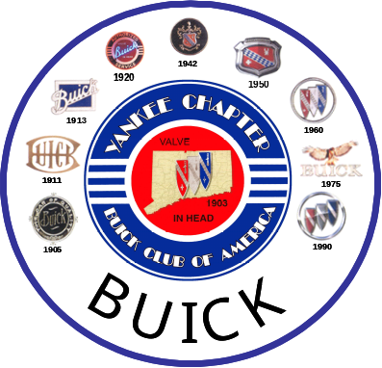

Date: _________ Renewal: _______ New Applicant: ___________

Name(s): _____________________________________________________

Address: _____________________________________________________

_____________________________Zip: ____________________

Phone: ( )_____________Email____________________________

Contact preference: Newsletter Phone Email

Year Buick Body Style & Model Number Condition
_________ ________________________ ________
_________ ________________________ ________
_________ ________________________ ________
_________ ________________________ ________

Your BCA Membership Number: _________________________________

Chapter dues are $20.00 per year and run from Jan thru Dec
Checks are made payable to: Yankee Chapter BCA
Please mail to: Glenn Tyler
54 Laurel Drive
Willington, CT 06279-2247

Please print legibly – Please update any changes via letter, phone (860) 684-7098

